1. Write a C Program to enter two numbers and find their sum.

CODE:

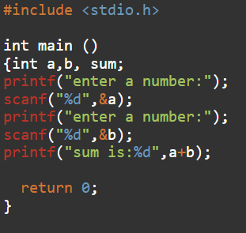

OUTPUT:



1. Write a C Program to enter two numbers and perform all arithmetic operations.

CODE:

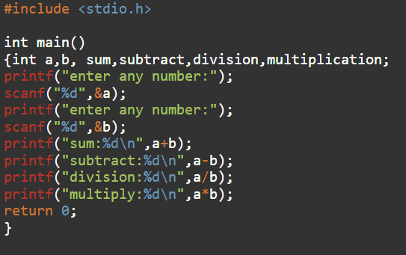

OUTPUT:

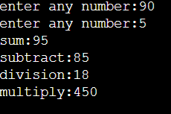

1. Write a C Program to enter length and breadth of a rectangle and find its perimeter.

CODE:

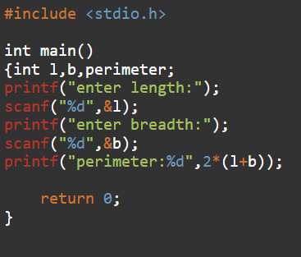

OUTPUT:

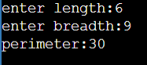

1. Write a C Program to enter the length and breadth and find its area.

CODE:

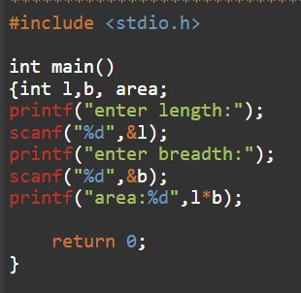

OUTPUT:

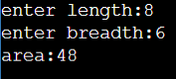

1. Write a C Program to enter radius of a circle and find its diameter, circumference and area.

CODE:

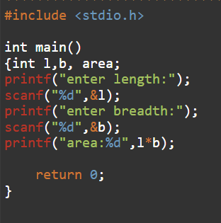

OUTPUT:

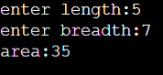

1. Write a C program to enter temperature in Celsius and convert it into Fahrenheit.

CODE:

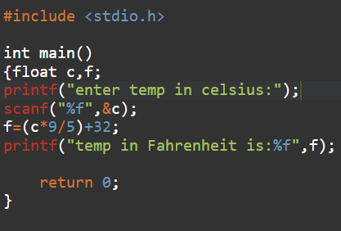

OUTPUT:

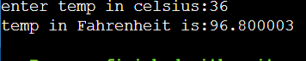

1. Write a C Program to enter length in centimetre and convert it into meter and kilometre

CODE:

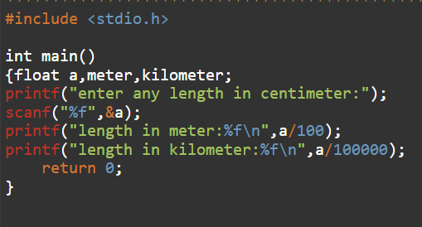

OUTPUT:

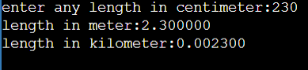

1. Write a C Program to enter temperature in Fahrenheit and convert it into Celsius.

CODE:

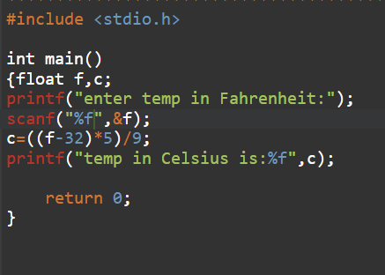

OUTPUT:

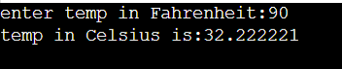

1. Write a C program to convert days into years, weeks and days.

CODE:

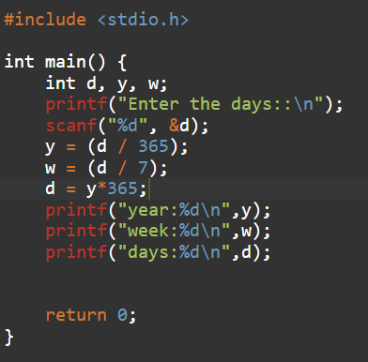

OUTPUT:

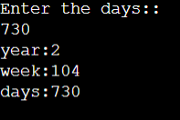

1. Write a C Program to find the power of any number X^Y.

CODE:

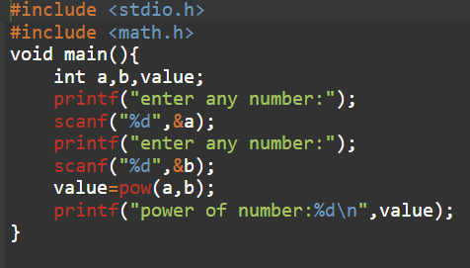

OUTPUT:

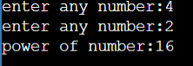

1. Write a C Program to enter any number and calculate its square root.

CODE:

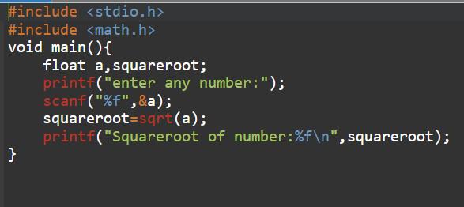

OUTPUT:

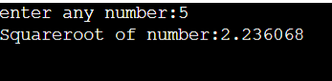

1. Write a C Program to enter two angles of a triangle and find the third angle.

CODE:

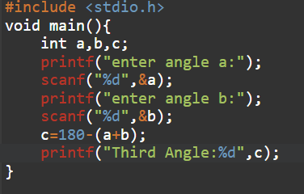

OUTPUT:

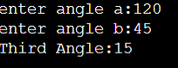

1. Write a C Program to enter base and height of a triangle and find its area.

CODE:

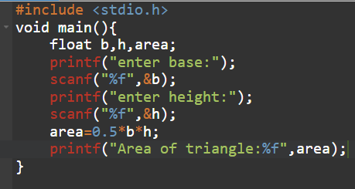

OUTPUT:

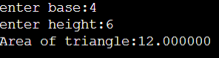

1. Write a C Program to calculate area of an equilateral triangle.

CODE:

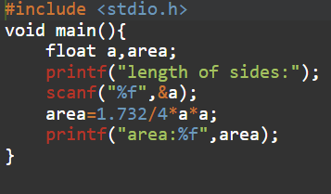

OUTPUT:



1. Write a C Program to enter marks of five subjects and find total, average and percentage.

CODE:

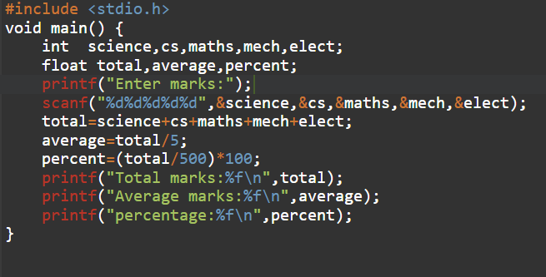

OUTPUT:

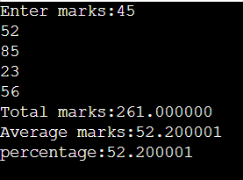

1. Write a C Program to enter P,T,R and calculate simple interest.

CODE:

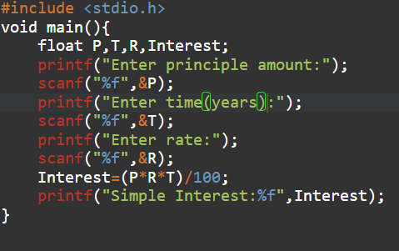

OUTPUT:

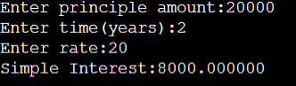

1. Write a c Program to enter P,T,R and calculate compound interest.

CODE:

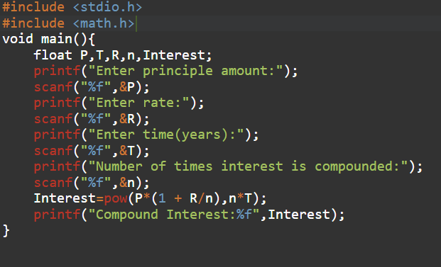

OUTPUT:

